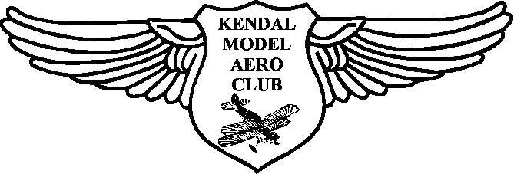
Adult Membership Application 2026
Full Name

Address

Post Code

Telephone Number

Email Address

By providing an email address, you agree to receiving communications, Newsletters etc. by email.

Are you a
member of the BMFA, SAA or LMA? Y/N If yes what is your membership number?

What is your main R/C channel number? (even channels only at the flying field)

What ratings, if any, awarded by the BMFA, SAA or LMA do you hold?

I declare that I shall fly in a safe manner, conform to the club rules and relevant laws and keep my third party liability insurance up to date. I also accept that the club, its officers and member can not be held responsible for any claim arising from my actions, or failure to comply with club or CAA regulations. I understand that Gas Turbine engines can only be used with the prior written approval of the club committee and models in excess of 7kg are prohibited at the Lyth Valley site. I accept that membership of the BMFA, SAA or LMA is compulsory and membership runs from the 1st January to the 31st December each year.
NOTE: CAA Registration requires an A or B Certificate OR BMFA Registration Competency Certificate

I enclose the subscription fee of: - | KMAC Adult Member | £50 .00
(Please delete those not required) | BMFA Fee | £51.00
 | New Member joining | £10.00
2026 Year | Total | £_____________

Signed
Bank Details Sort Code 40-33-28 Acc No.31383574 Kendal Model Aero Club
Once completed please send with the relevant subscription (payable to Kendal Model Aero Club) to: - Andrew McClure, 11 Sheepbarrow Close, Lindale, Grange Over Sands. LA11 6PB

